**Working with File Listeners& Service File:**

**File Listener:**

**File Listener Monitors a directory path on server, if a file is been placed listener picks the file & give it to service file rule**

**Service File:This rule accepts file input, reads the file content & process it by executing activity.**

**To work with file listener we will create below rules:**

**Service file**

**Parse Rule**

**Activity**

**File listener**

**Service Package**

**Data Table**

**---**

**First Create a CSV ( Comma Delimited File)**

**Open Micro soft Excel File**

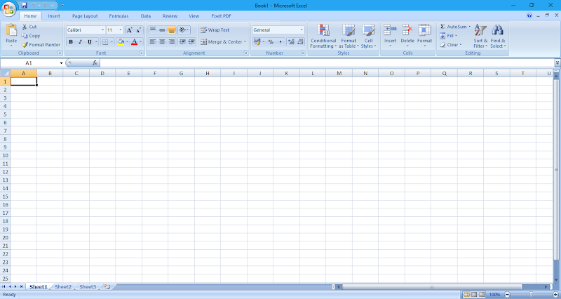

**Use Saveas Option**

**Select the File Type: CSV(Comma Delimited)**

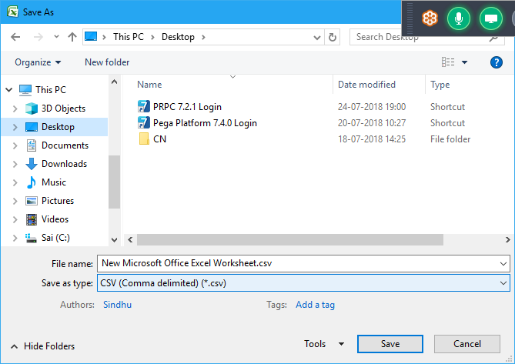

**Add Records like CustID ,FName&LName& Save the file.**

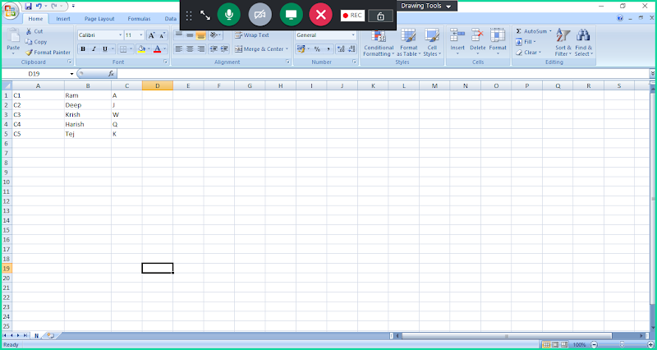

**Save File**

**Req: Insert Data from File to Customer Table by using Service File:**

**Use Existing Customer Table:**

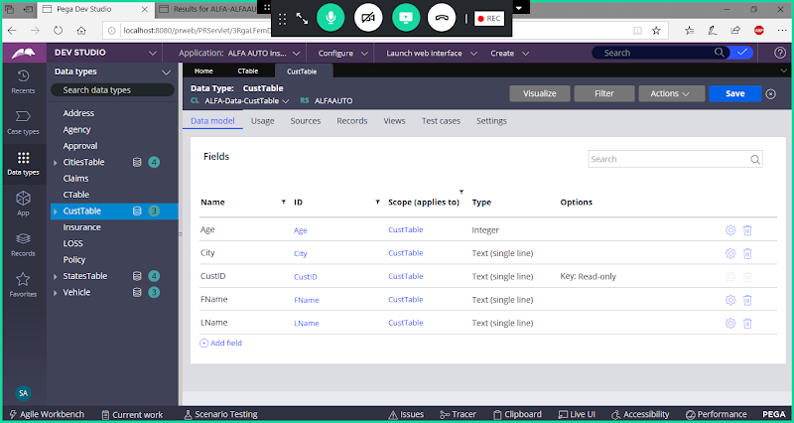

**Create Service Package:( If Package Rule is there Skip this Step)**

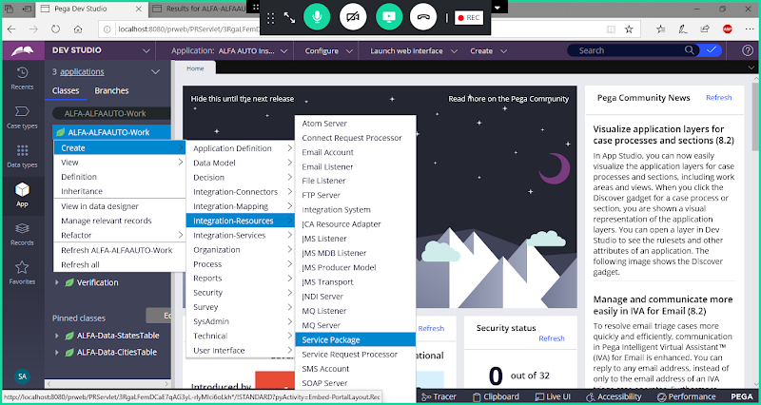

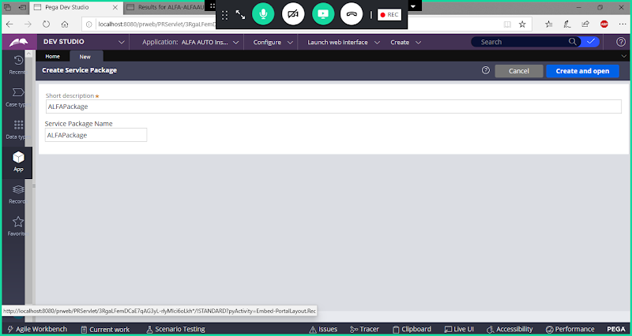

Open

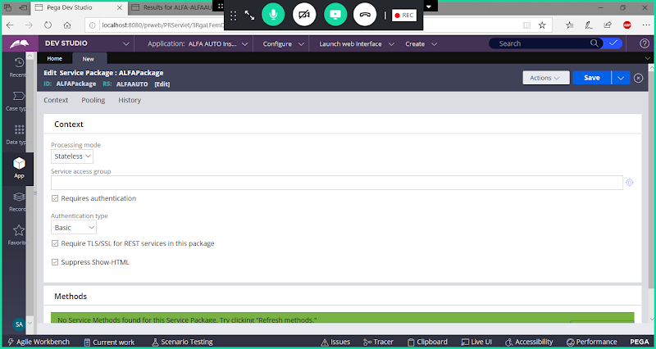

**Add Access Group Name:**

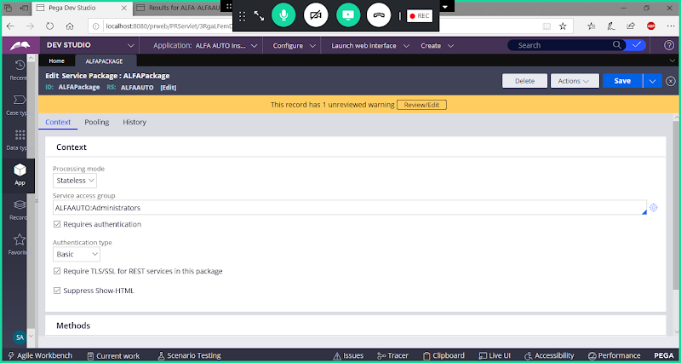

**Uncheck Requires Authentication**

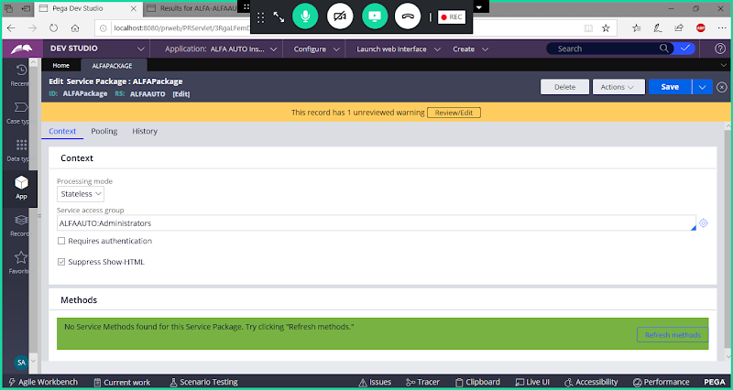

**Save the Package**

**Create a Service File Rule under Work Class:**

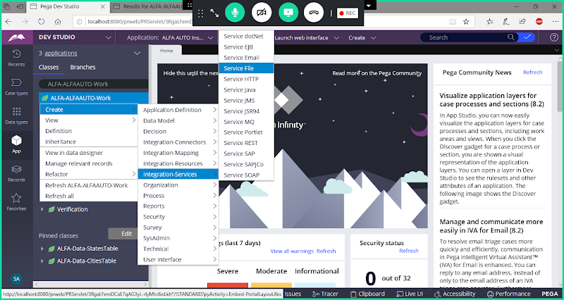

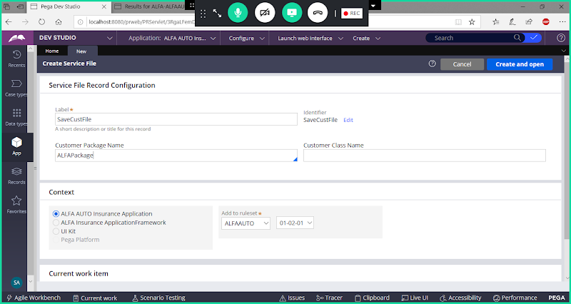

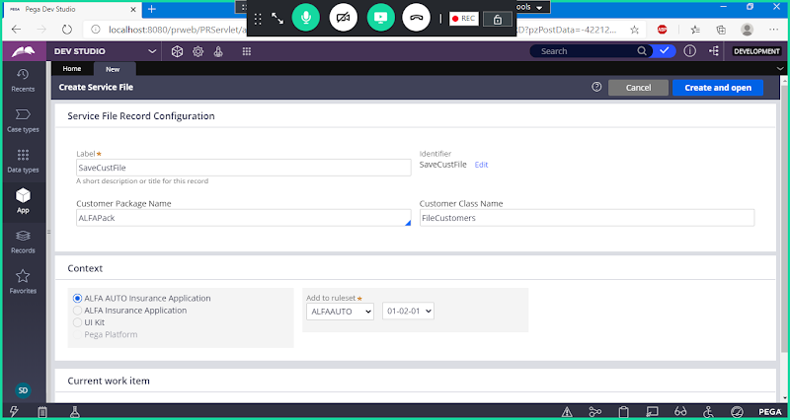

**Open**

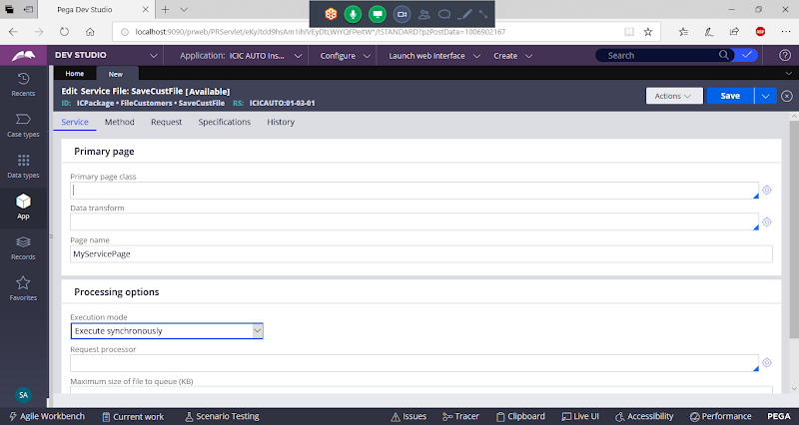

**Add Data Class Name & Change Page Name:**

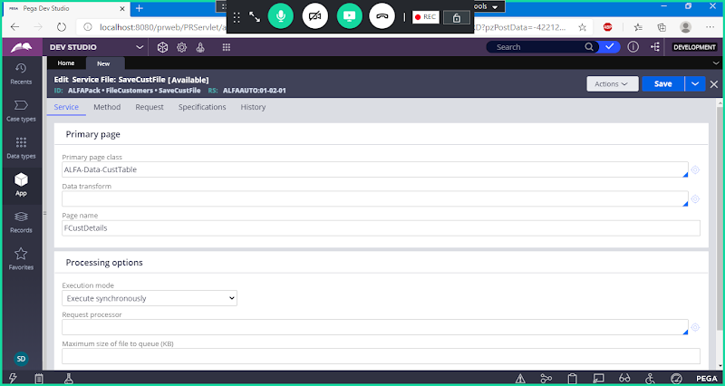

**Go to Method Tab:**

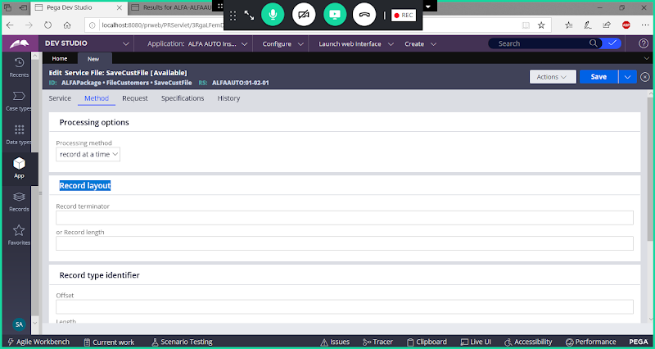

**Add Record Terminator**

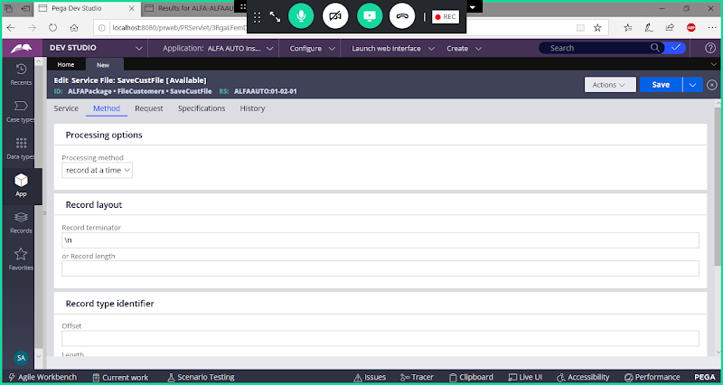

**\n : system will know whether row is completed or not by using \n**

**Go to Request tab:**

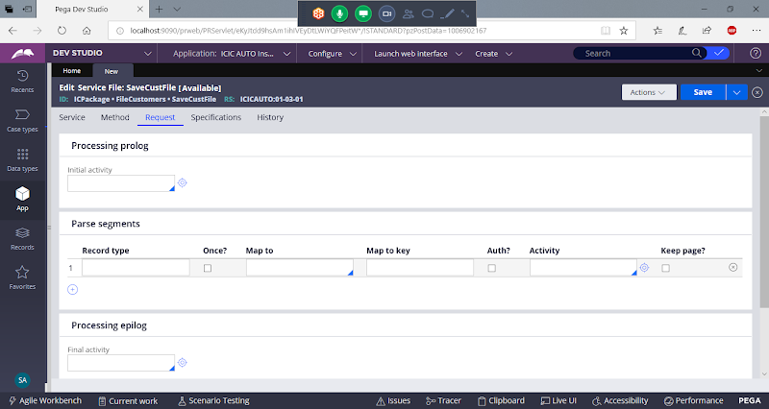

**Under Parse Segments:**

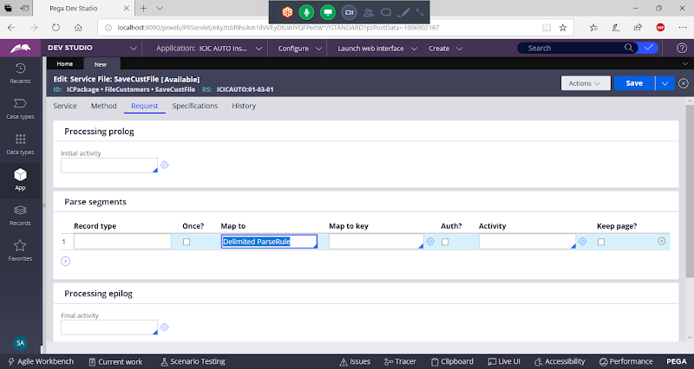

**Under Map to Key -> Open the Rule ( Click on Circle) ( Parse rule will be created under Data Class)**

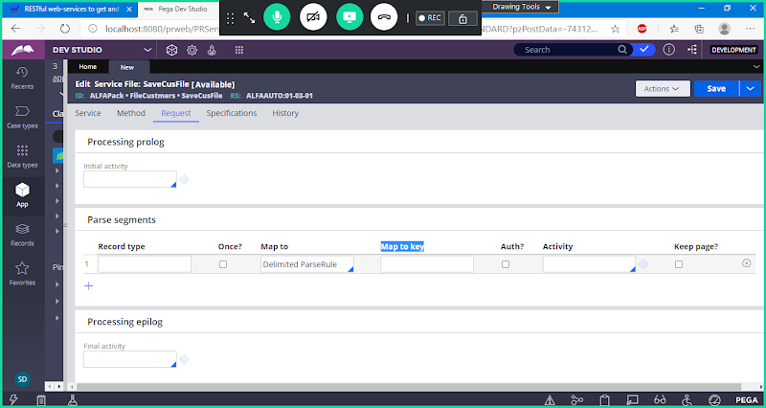

**Open Cust Table Class From App Explorer:**

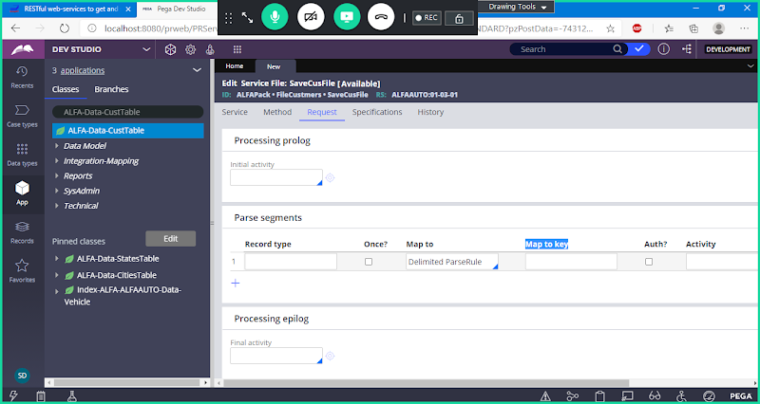

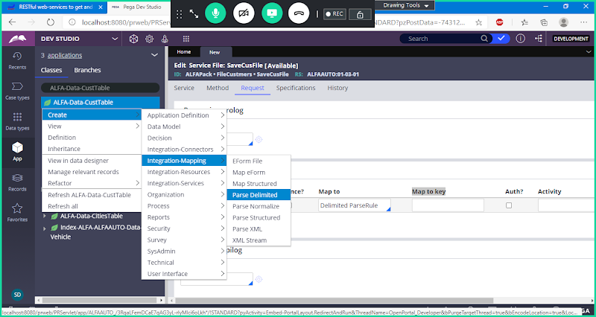

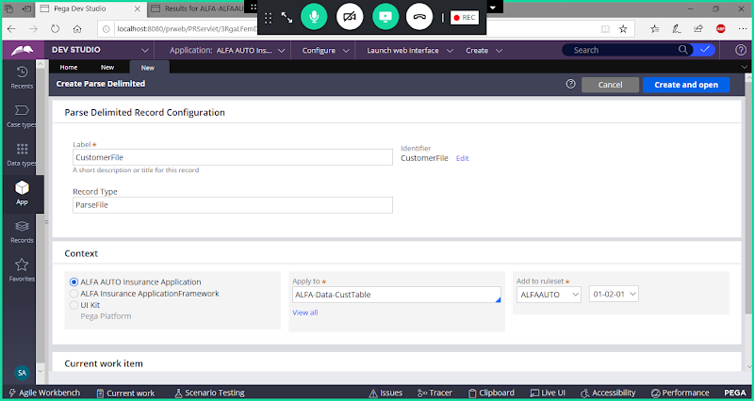

**Open**

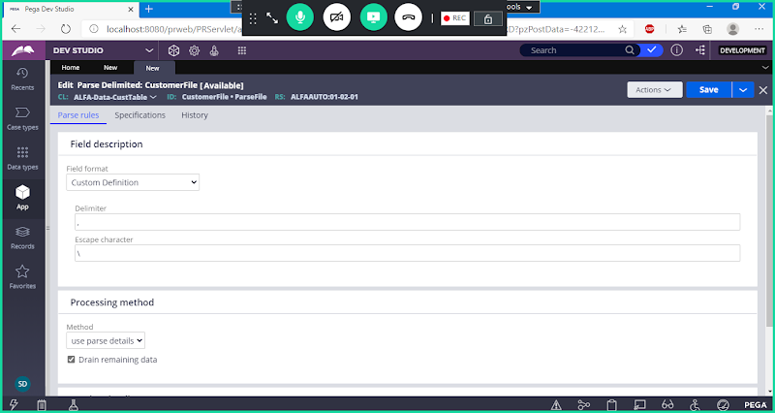

**Change Filed Format to Comma Sepeared Values**

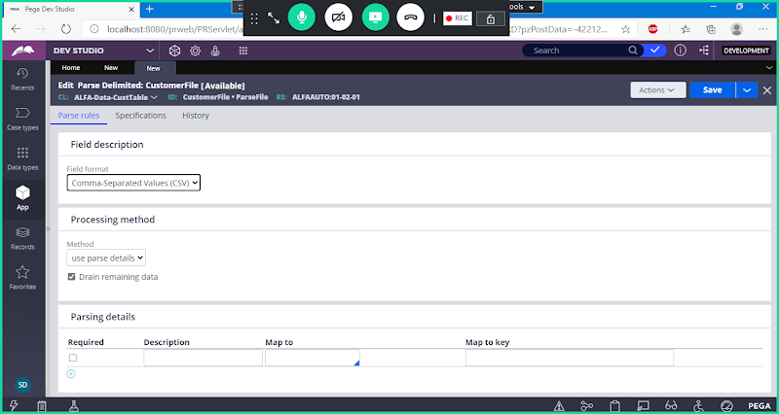

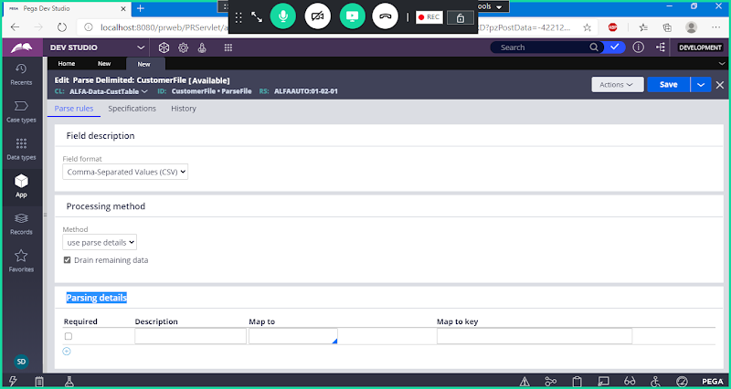

**Scroll Down:**

**Parsing Details**

**Now Map Fields:**

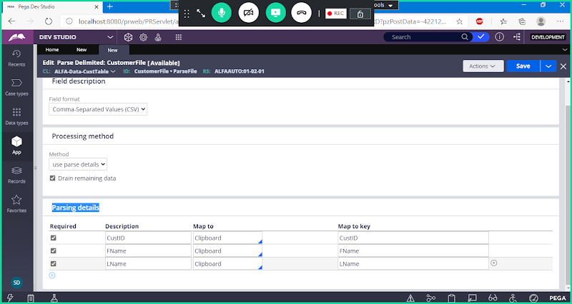

**Save Parse Rule.**

**Call Parse Rule in Service File under Map to Key:**

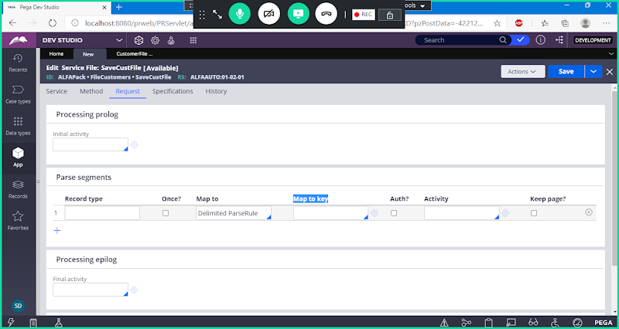

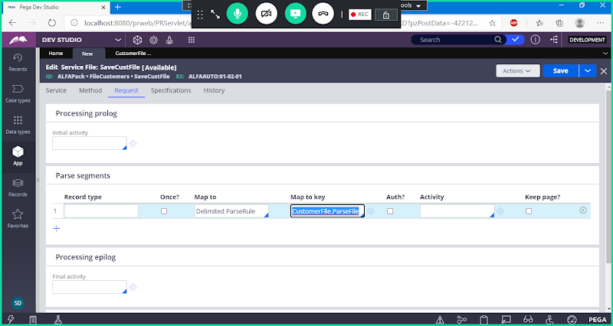

**Now Create Activity-> Open Activity Rule from Circle**

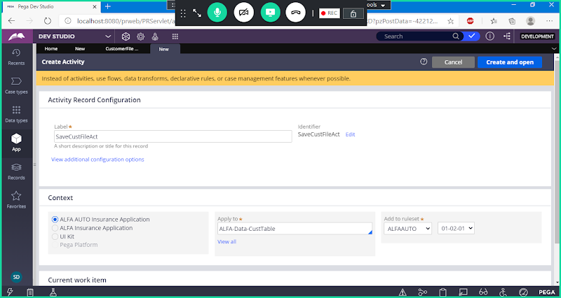

**Open**

**Go to Pages & Classes**

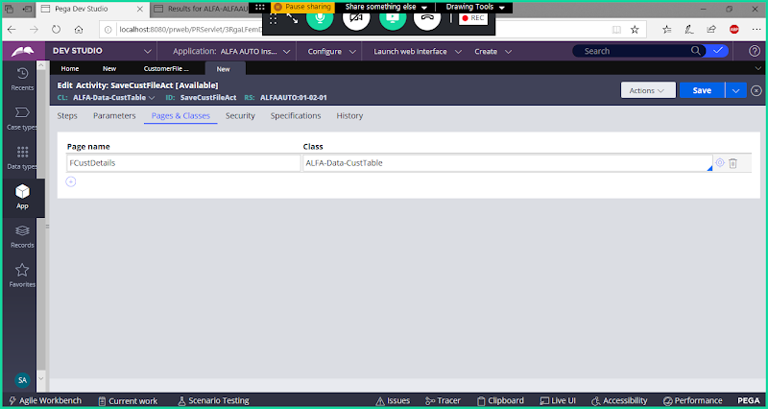

**In Above step Givepagename which is given in Service file rule:**

**Go to steps Tab:**

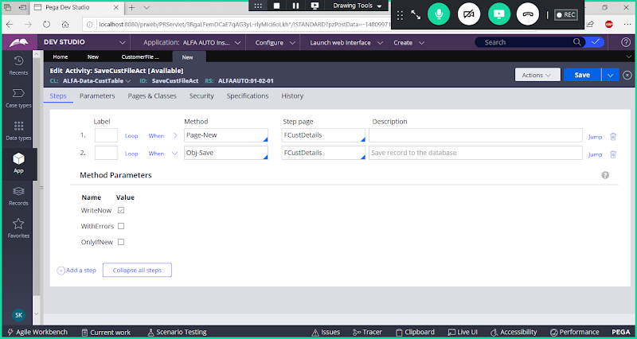

**Go to Security tab:**

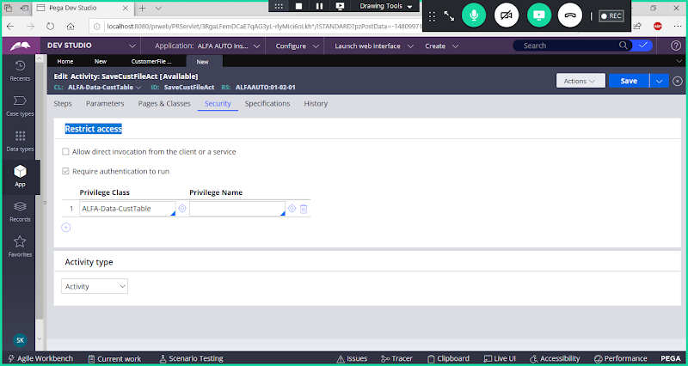

**Change Restrict Access options as shown in below screen:**

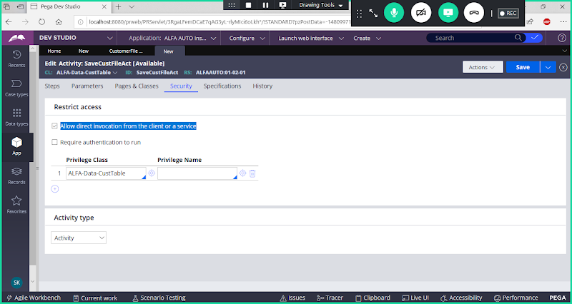

**Save Activity**

**Call Activity in Service Rule under Request tab:**

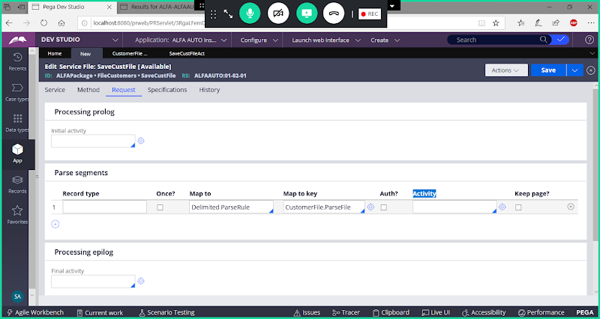

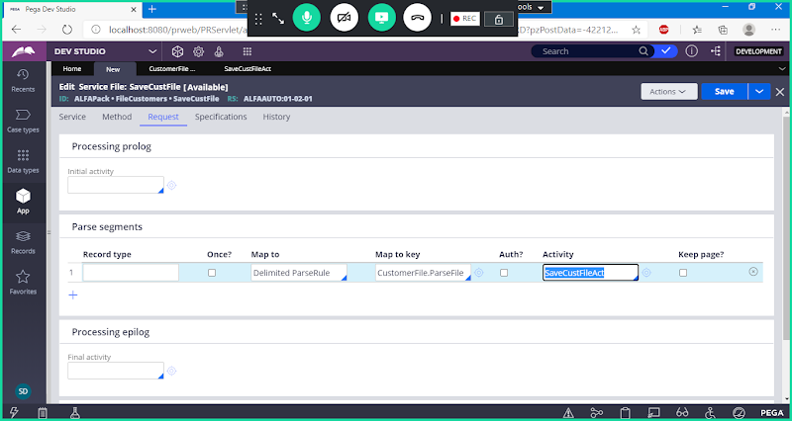

**Save Service File.**

**Create a Directory Path ( Folder) under any Drive: Folder Name ( ABCDir)**

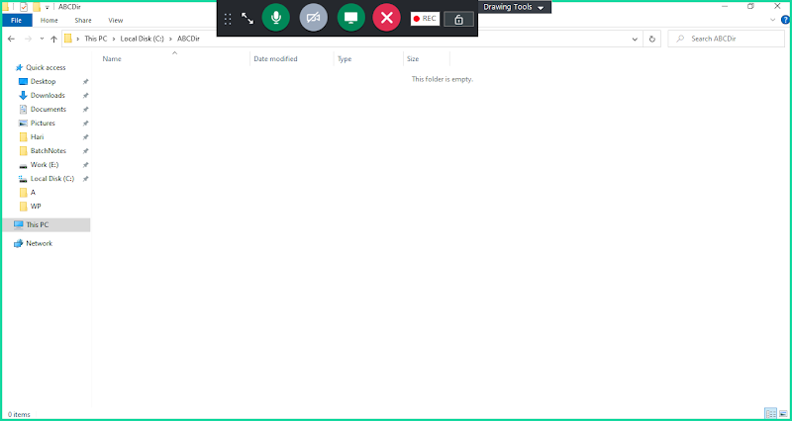

**Create File Listener:**

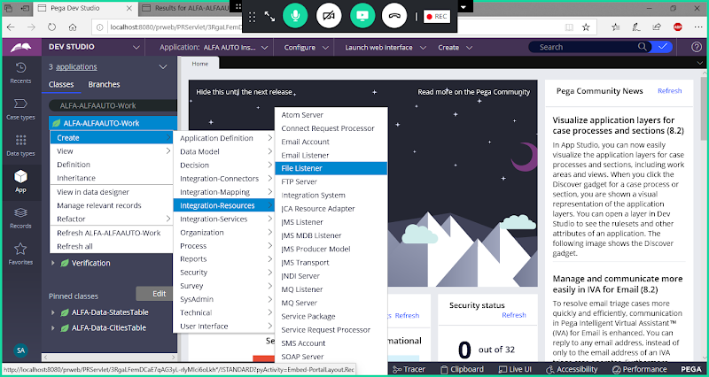

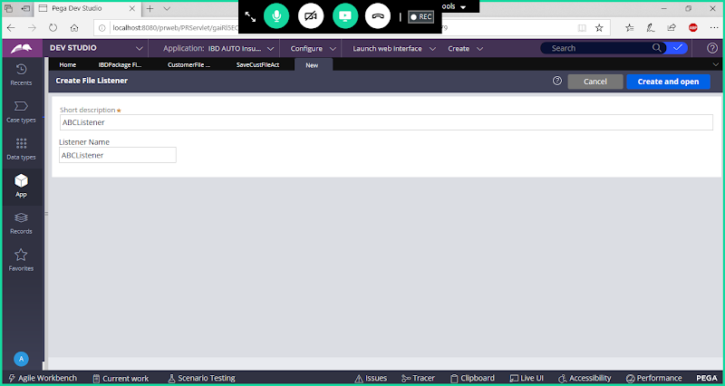

**Open**

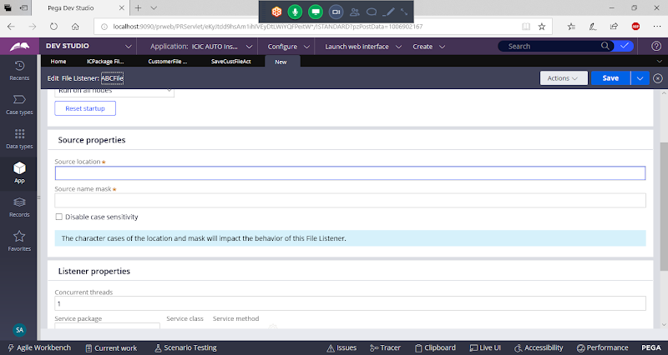

**Dirname:  C:\ABCDir\**

**Source Name: *.csv**

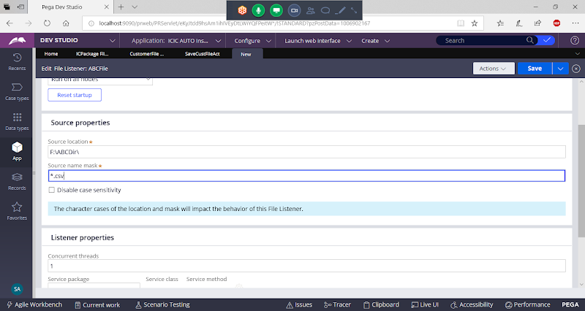

**Scroll down:**

**Configure Listener Properties**

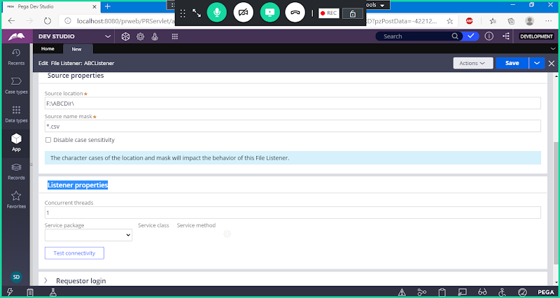

**Add Service Package , Service Class & Method from dropdown:**

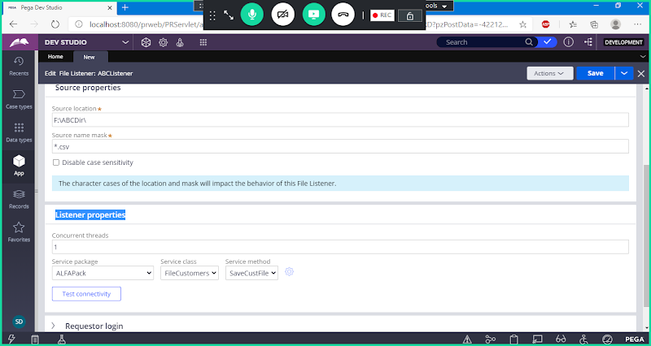

**Save Rule**

**Now Click on Test Connectivity:**

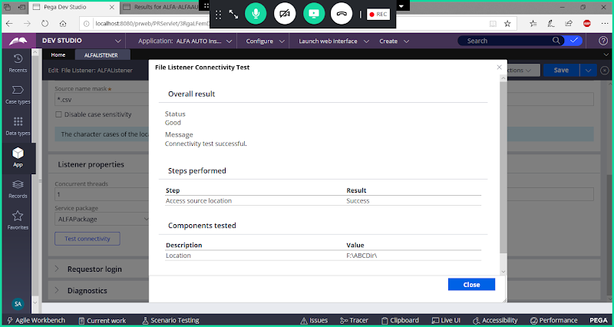

**Click on Close**

**Now go to Process Tab:**

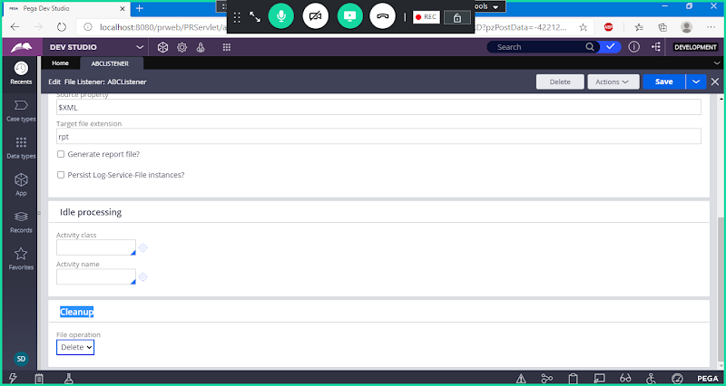

**Cleanup -> Select Keep**

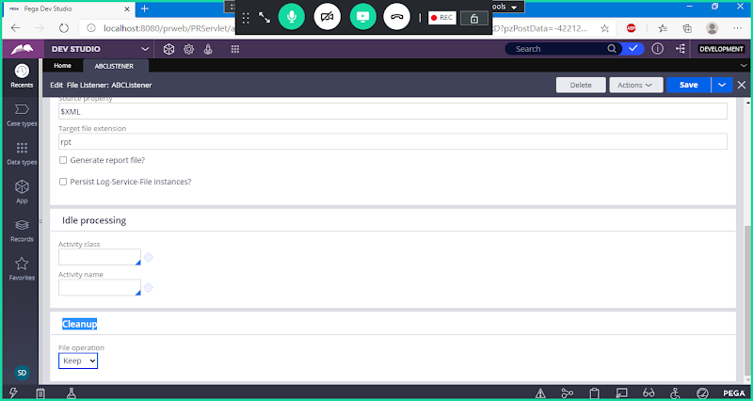

**Save File Listener**

**How to Listener UP to 7.4 Version:**

**Now Configure SMA ( Listener)**

**Open SMA -> Open Node & Go to Listener Management**

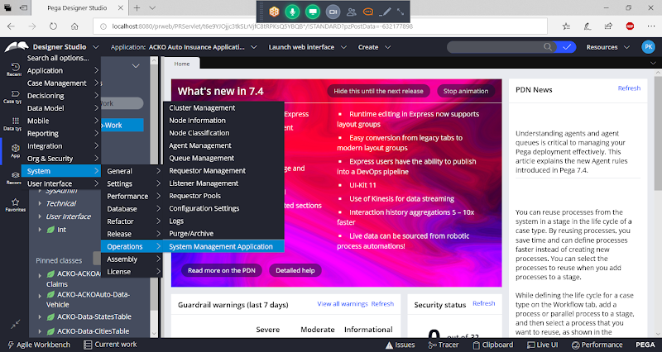

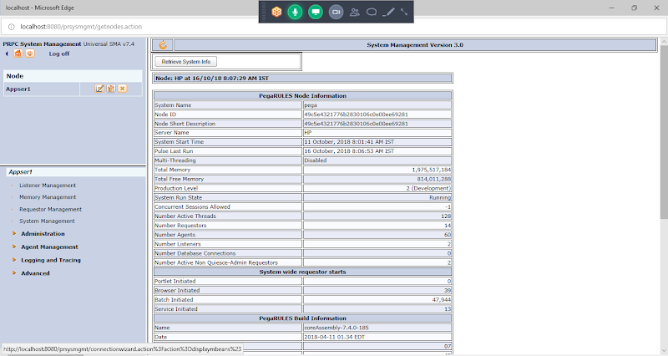

**Go to Listener Management**

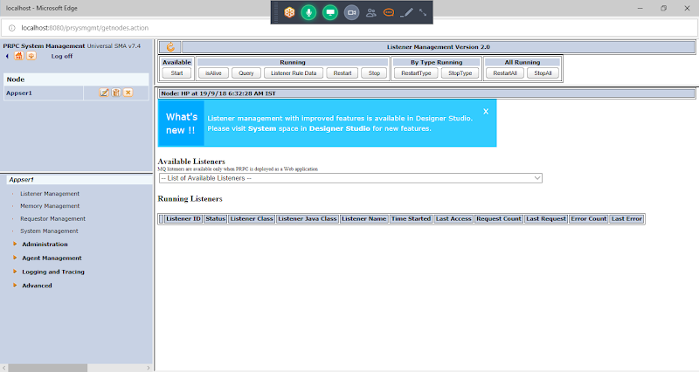

**Under Available Listeners**

**Select Ur File Listener: ( ABCFile)**

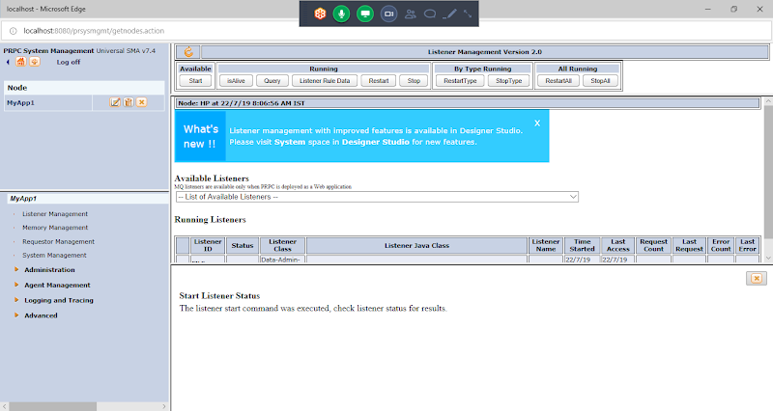

**Click on Start**

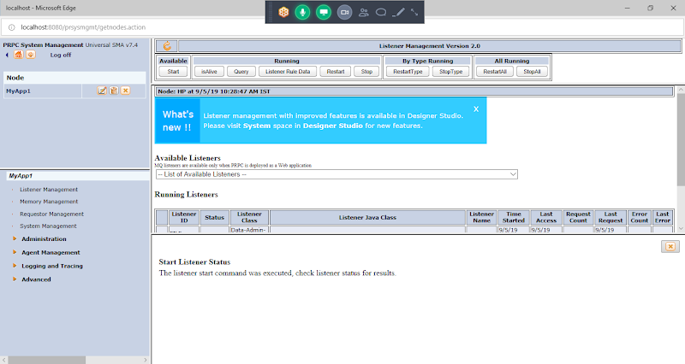

**Now go to directory**

**Copy ur File in the Directory Folder ->**

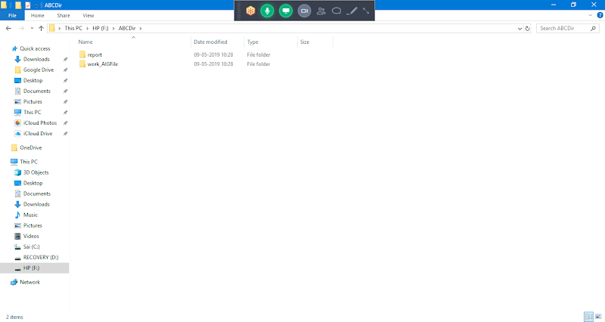

**Copy File**

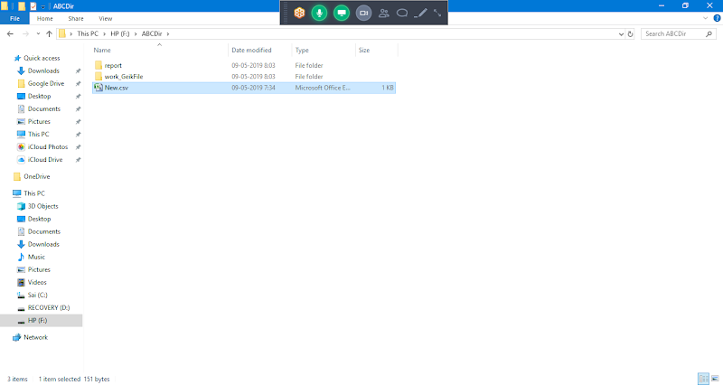

**Check after 30 seconds. Listener will pick the file for every 30 sec**

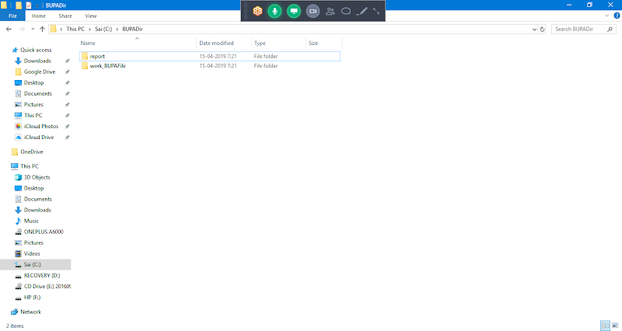

**Now File has been picked from the directory path & Service File Read the File & Process the File.**

**The Records in the file will be saved to Customer Table:**

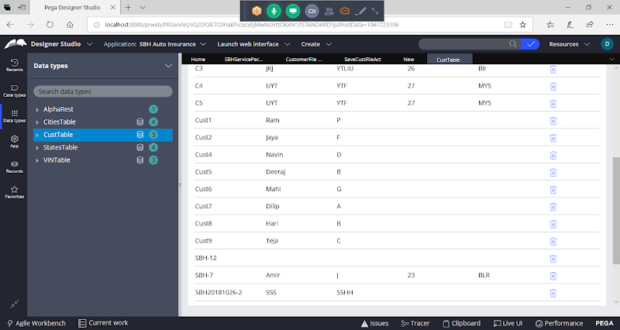

**==========**

**How to Start Listener in 8 Version:**

**Switch to Admin Studio:**

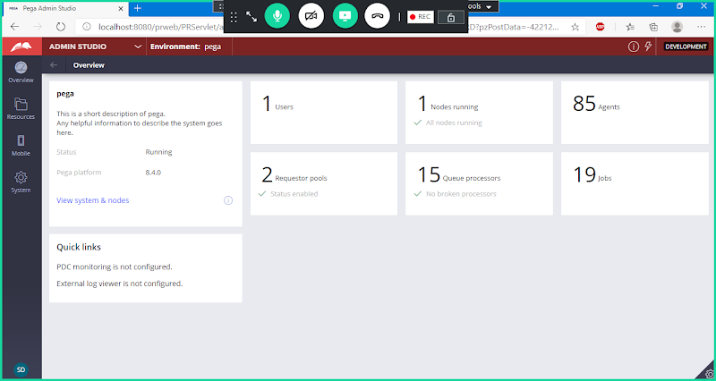

**Go to Resources**

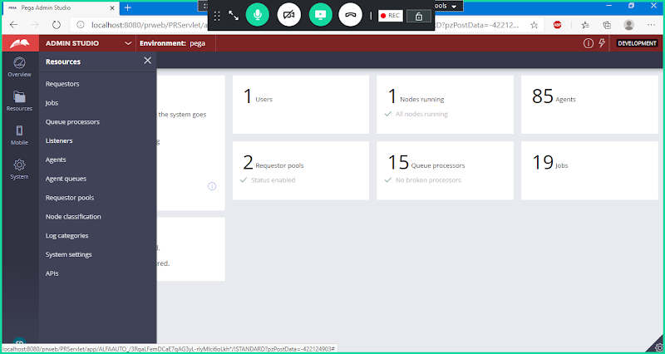

**Click on Listeners**

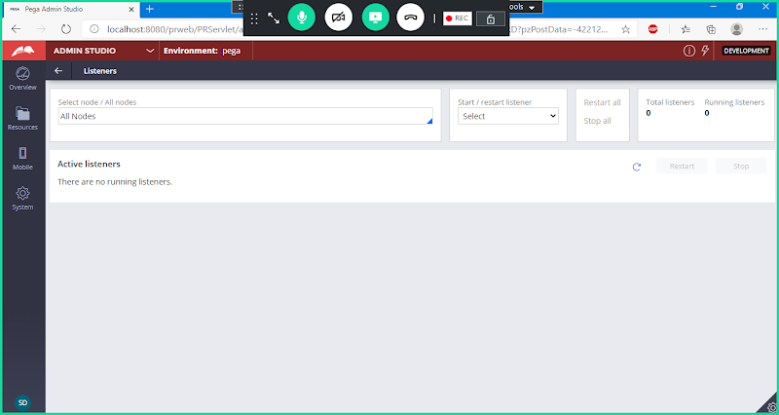

**Under Start/Restart Listener - > Start a New Instance**

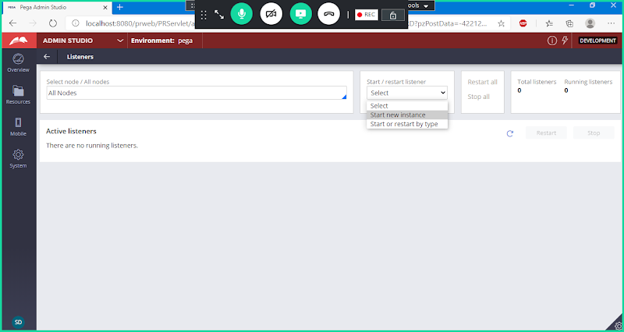

**Now Select Listener Name**

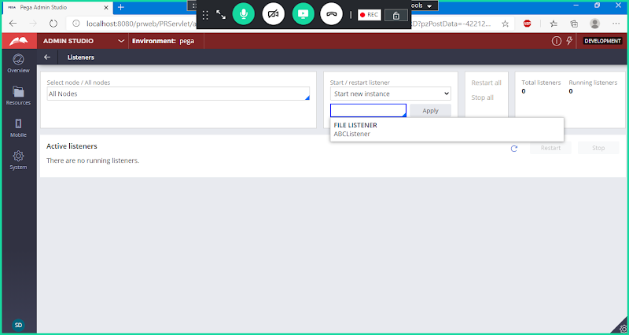

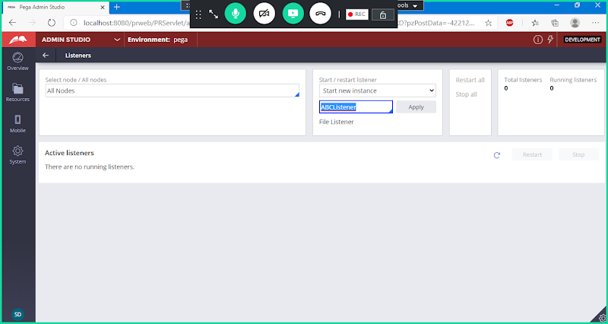

**Click on Apply**

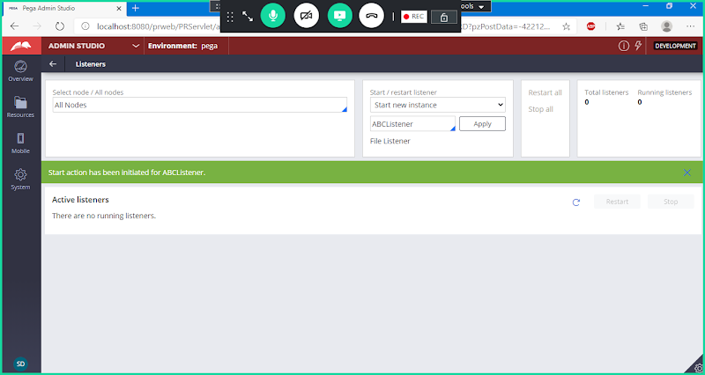

**Now Open Directory Path & Copy CSV file to Directory**

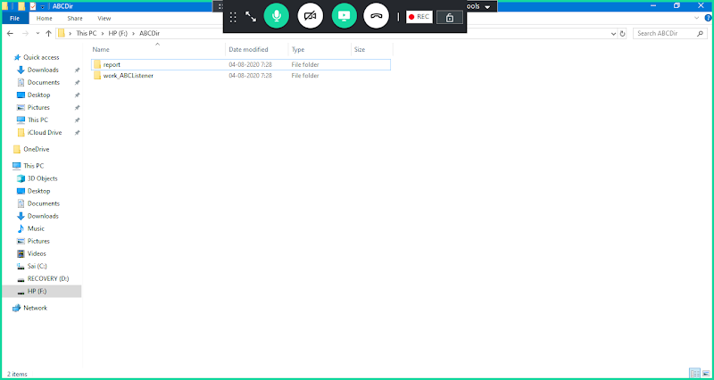

**Now Paste CSV file under Directory Folder**

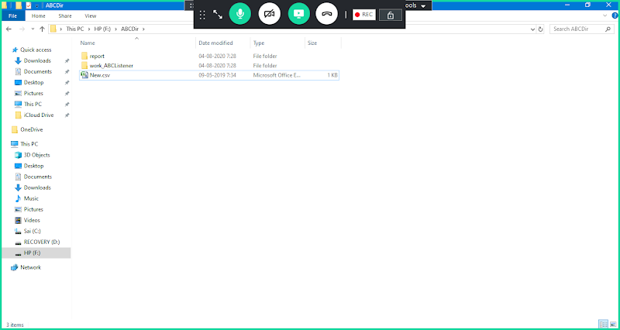

**After 30 Seconds Listener will pick up the file ( It will refresh for every 30 sec)**

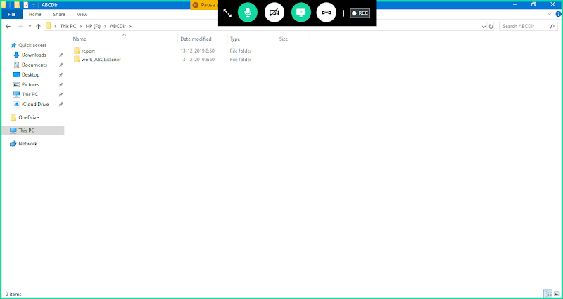

**Now File has been picked from the directory path & Service File Read the File & Process the File.**

**The Records in the file will be saved to Customer Table:**

